# **Sprint Retrospective (sprint 2)** November 2nd

**Scrum Master: Braysen**

o What went well

Did good planning setup

o What didn't go well

We did not finish all that we planned

o What specific things you can do to improve

Better time management (set aside more time to work on the project).

o List the measurement criteria

|  |  |  |  |
| --- | --- | --- | --- |
| Name | Stayed close to the plan for the sprint | Percentage of work done | Stress |
| Peter Allen (vanished) | ? | ? | ? |
| Nathan Johnson | 20 (changed responsibilities) | 5 (did more practice than work toward a specific task) | 50 (trying to connect the dots with fixing errors) |
| Jared Scottt | 35 | 35 | 30 |
| Braysen Goodwin | 45 (used stack before) | 55 (almost completed server) | 15 |

**Sprint Planning 3 - Nov 2 to Nov 13:**

User Stories Supported With Code:

Account Information Change small 5% *this sprint

* A user should be able to change the information on their account

Managing User Accounts small 5% *this sprint

* An manager should be able to change the roles on other users

Restock/Discard Inventory medium 10% *this sprint

* A chef should be able to add and remove stock from inventory

Place Order large 15% *this sprint

* A customer should be able to place an order
  + Customer can pick any number of bagels
  + Customer can pick any number of toppings for the bagel
  + Customer can place order (if user has adequate funds)
  + Customer will receive prompt they do not have adequate funds if applicable

Marking Order As Picked Up medium 10% this sprint to next

* A cashier should be able to mark an order as picked up

Marking Order As Prepared medium 10% next sprint

* A chef should be able to mark an order as prepared

Viewing and Printing Analytics medium 10% next sprint

* A manager should be able to view order and menu analytics

Unit tests of created logic large 15% next sprint

* Tests should be able to detect problems in the code

*Leftover bugs and such for final* 20%

Create Navigable Pages:

HomePage:

Order Page:

Chef Order Page:

Cashier Page:

Inventory Page:

Account Page:  
 Account Database:

Inventory Database:

Order Database:

Unit Tests covering major logic:

Order placement

Inventory management

Account creation

**Burn Down**

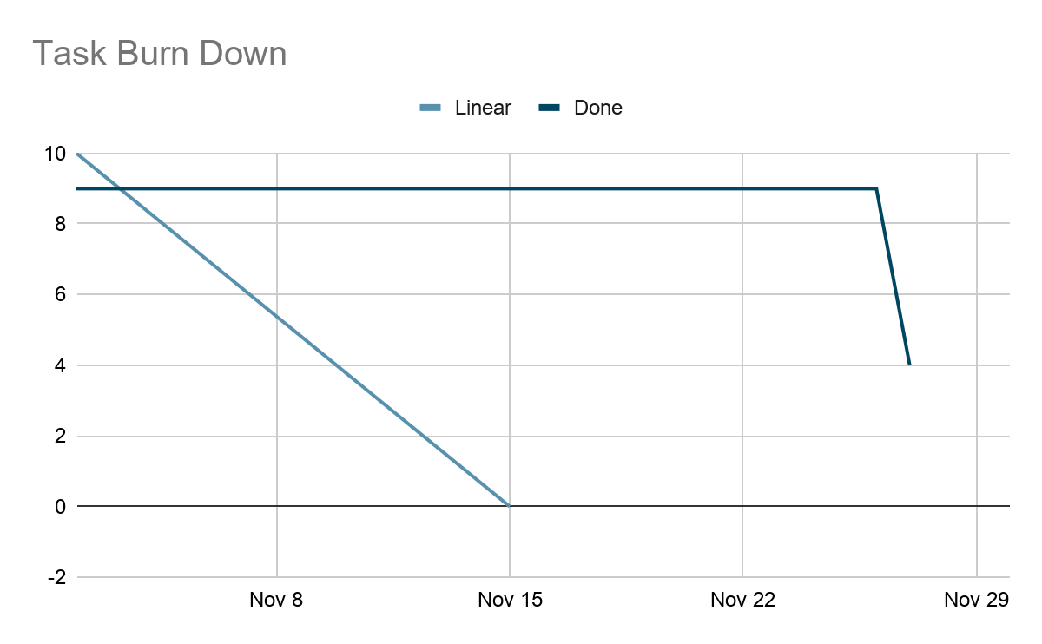

# 

# 

# 

# 

# 

**Standup Summaries**

**Nov 2, 2020:**

Worked on:

Braysen: finished most of the backend. Nathan is transitioning to the front end (as he did not do that much on the backend). Jared: Started working on a home page using the general components.

Concerns:

The front end is behind. But the server should be finished (except for bugs). Also Peter is missing, we have not been able to communicate with him and he disappeared from discord.

Today:

Braysen:

Finish the backend and tests. And help with front-end when questions are asked.

Nathan:

Learn the stack for front end. And help with communication between front end and server.

Jared:

Get front-end pages setup

**Nov 4, 2020:**

Worked on:

Braysen finished the backend. Nathan worked on the registration page.

Jared: Working on the theme of the front end pages.

Concerns:

Peter is missing, adapting sprints and tasks to deal with it.

Today:

Braysen:

Help with front-end when questions are asked. And fix any bugs that may arise with the backend.

Nathan:

Finish registration and authentication.

Jared:

Get front pages styled.

**Nov 6, 2020:**

Worked on:

Braysen: Fixed a bug with the authentication routes. Nathan worked on the registration page.

Jared: Created front end routes for the home and orders pages.

Concerns:

We over loaded the tasks on this sprint.

Today:

Braysen:

Help with front-end when questions are asked. And fix any bugs that may arise with the backend.

Nathan:

Write the profile fetching.

Jared:

Finish front page and adapt order form.

**Nov 9, 2020:**

Worked on:

Jared: Finished theming the home page.

Nathan: Added logout button.

Braysen: Did not work on the project this weekend.

Concerns:

We over loaded the tasks on this sprint… and we have a meeting with the profesor today

Today:

Braysen:

Help with front-end when questions are asked. And fix any bugs that may arise with the backend.

Nathan:

Write the profile fetching.

Jared:

Finish front page and adapt order form.

**Nov 11, 2020:**

Worked on:

Jared: Worked on the order page, added more content to the home page.

Nathan: Finished profile fetching.

Concerns:

We are behind.

Today:

Braysen:

Help with front-end when questions are asked. And fix any bugs that may arise with the backend.

Nathan:

Write the inventory page.

Jared:

Finish front page.

**Nov 13, 2020:**

Worked on:

Baysen fixed bugs on the server.

Nathan: Added front end to populate the database.

Jared: Worked on styling the UI for the new pages.

Concerns:

We are very far behind.

Today:

Braysen:

Help with front-end when questions are asked. And fix any bugs that may arise with the backend.

Nathan:

Finish inventory page.

Jared:

Finish styling and bug fixes on all current pages.